KING FAHD UNIVERSITY OF PETROLEUM AND MINERALS
DEPARTMENT OF PHYSICS
PHYS 422-222
Nuclear and Partcile Physics
HW-9 Solutions
Due by 09 April 2023
Problems are from Ch.11 of Textbook and are equally weighted (5 pts each)
Attempt the problems by yourself first, and then seek help if needed.
If you use a reference/solution manual, mention it and you will get full credit for a correct answer.
Please submit good PDF copy by email to khiari@kfupm.edu.sa
Q1. Pb # 11.12
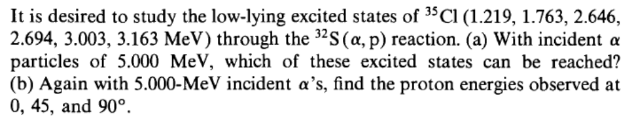
Solution
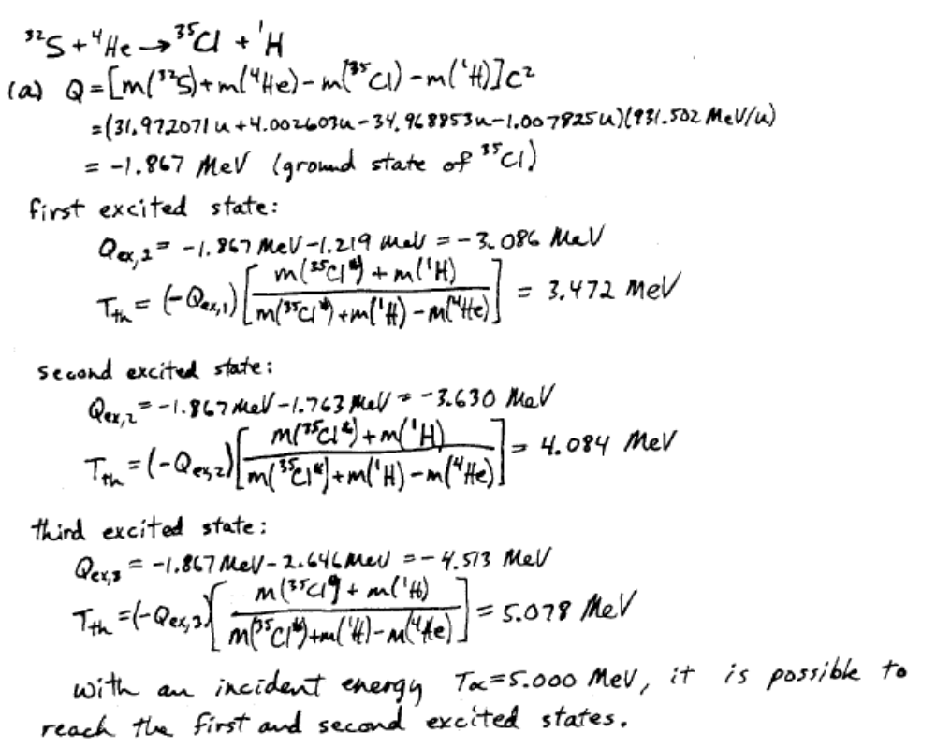
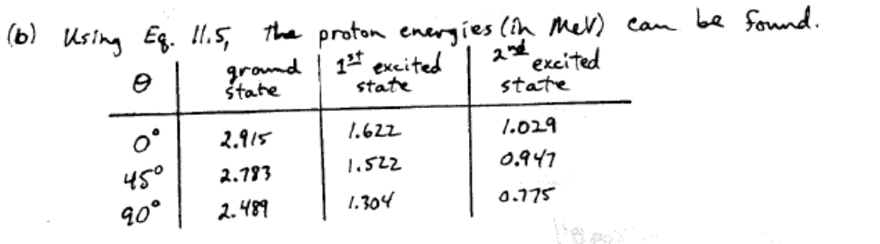

Q2. Pb # 11.13
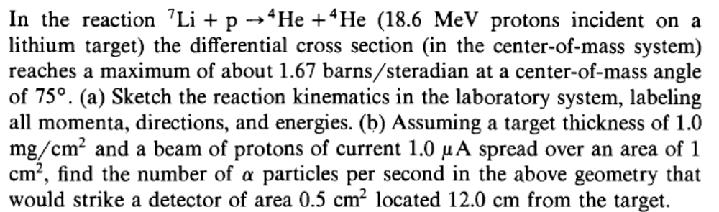
Solution
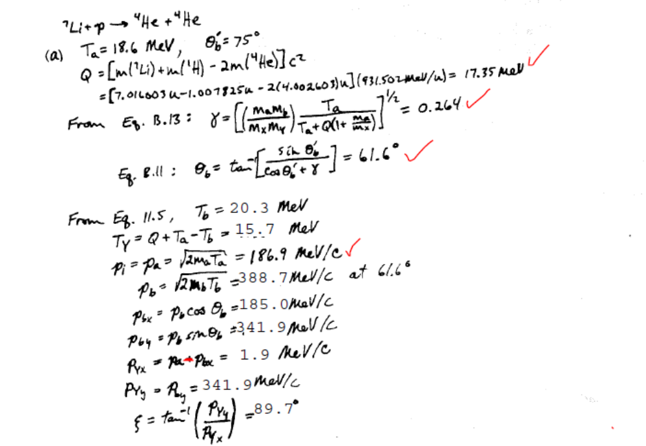
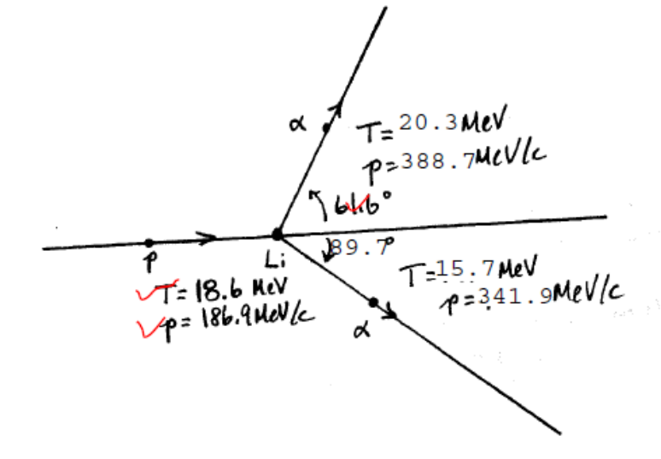

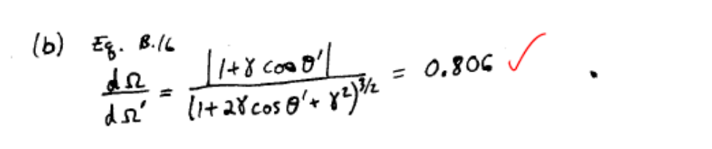
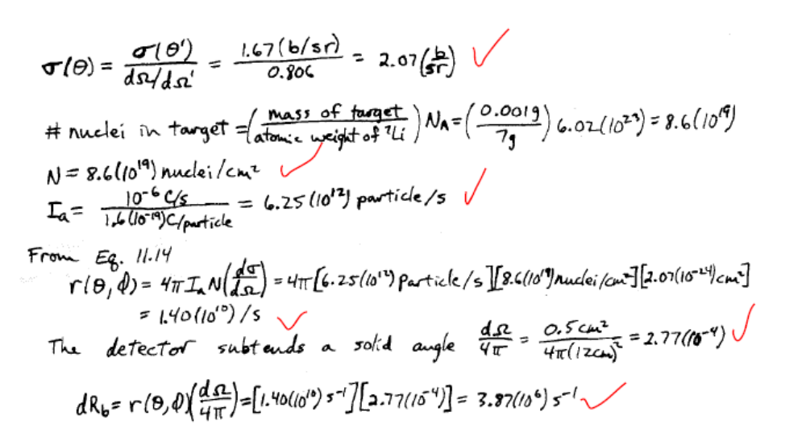
Q3. Pb # 11.14
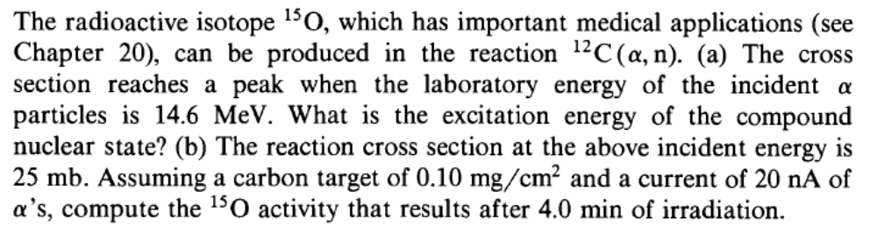
Solution
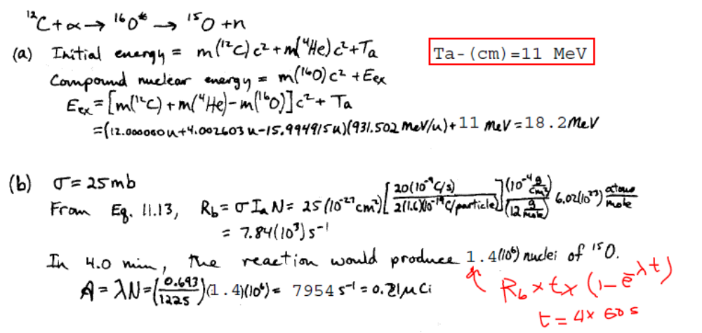

Q4. Pb # 11.17
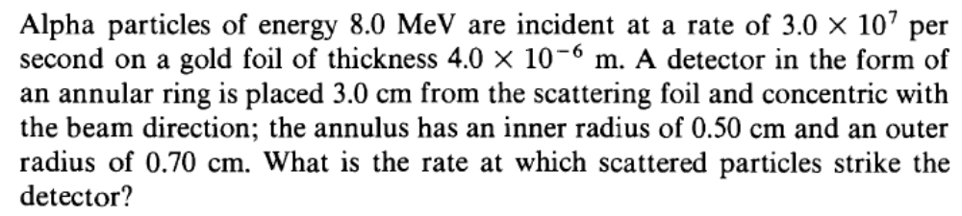
Solution
